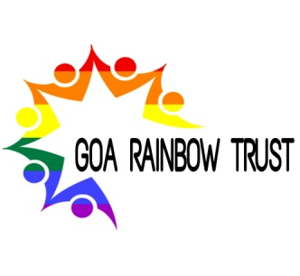
Goa Rainbow Trust
St. Britto’s apts, S7/8, @nd Floor, near New Mapusa
(Attach your picture here)
clininc, Fiera Alth,Mapusa Bardez, Goa-403507
Contact No.: 8552017179

TRUST MEMBERSHIP APPLICATION FORM
As the prospective trust members, you should be aware of the essence and motto of the trust. GRT is liberal creative space that works towards making changes in the society that matter, regarding LGBTQ+ community. When you join us as a trustee, you partake the moral and social responsibility regarding these the community and promise to work towards the uplifting them with an unbiased approach.
Contact information (Fill in BLOCK LETTERS)
First Name: | Middle Name: |  |  | Last Name:
Email ID: | Contact No.: |  |  | D.O.B: |  | Sex:
Address:
City: | State: |  |  | Zip:
Employment: | Organization: |  |  | Position:
Emergency contact
Full Name: |  | Relation: |  | Contact No.:
Past Experience
Special skills or qualifications:

Any previous experience with any other organization:
Organization:

For Office Use (Applicants need not fill this)
Department: |  |  | Hierarchy:
JD: |  |  |  |  | Supervision:
Signature of Member Date of Submission Seal of Organization
The applications can reach us :
Through the official email ID (goarainbowtrust@gmail.com), manually handed to Admin or on official trust address.
Important notes :
Attach a valid ID proof and a passport sized photo of yourself to the form.
Any criminal charges or records can get in the way of your membership depending on their nature as the trust works on the principals of law.

